Linux Cheat Sheet

Introduction:
Purpose of this document is to identify and make some practices in the Linux.

Contents:
Followings are the basic command, as a DevOps resource have to well-versed in the following command.

- SYSTEM INFORMATION
- HARDWARE INFORMATION
- PERFORMANCE MONITORING AND STATISTICS
- USER INFORMATION AND MANAGEMENT
- FILE AND DIRECTORY COMMANDS
- PROCESS MANAGEMENT
- FILE PERMISSIONS
- NETWORKING
- ARCHIVES (TAR FILES)
- INSTALLING PACKAGES
- SEARCH
- SSH LOGINS
- FILE TRANSFERS
- DISK USAGE
- DIRECTORY NAVIGATION

1 – SYSTEM INFORMATION
# Display Linux system information
uname -a

# Display kernel release information
uname -r

# Show which version of redhat installed
cat /etc/redhat-release

# Show how long the system has been running + load
uptime

# Show system host name
hostname

# Display the IP addresses of the host
hostname -I

# Show system reboot history
last reboot

# Show the current date and time
date

# Show this month's calendar
cal

# Display who is online
w

# Who you are logged in as
whoami

2 – HARDWARE INFORMATION
# Display messages in kernel ring buffer
dmesg

# Display CPU information
cat /proc/cpuinfo

# Display memory information
cat /proc/meminfo

# Display free and used memory ( -h for human readable, -m for MB, -g for GB.)
free -h

# Display PCI devices
lspci -tv

# Display USB devices
lsusb -tv

# Display DMI/SMBIOS (hardware info) from the BIOS
dmidecode

# Show info about disk sda
hdparm -i /dev/sda

# Perform a read speed test on disk sda
hdparm -tT /dev/sda

# Test for unreadable blocks on disk sda
badblocks -s /dev/sda

3 – PERFORMANCE MONITORING AND STATISTICS
# Display and manage the top processes
top

# Interactive process viewer (top alternative)
htop

# Display processor related statistics
mpstat 1

# Display virtual memory statistics
vmstat 1

# Display I/O statistics
iostat 1

# Display the last 100 syslog messages (Use /var/log/syslog for Debian based systems.)
tail 100 /var/log/messages

# Capture and display all packets on interface eth0
tcpdump -i eth0

# Monitor all traffic on port 80 ( HTTP )
tcpdump -i eth0 'port 80'

# List all open files on the system
lsof

# List files opened by user
lsof -u user

# Display free and used memory ( -h for human readable, -m for MB, -g for GB.)
free -h

# Execute "df -h", showing periodic updates
watch df –h

4 – USER INFORMATION AND MANAGEMENT
# Display the user and group ids of your current user.
id

# Display the last users who have logged onto the system.
last

# Show who is logged into the system.
who

# Show who is logged in and what they are doing.
w

# Create a group named "test".
groupadd test

# Create an account named john, with a comment of "John Smith" and create the user's home directory.
useradd -c "John Smith" -m john

# Delete the john account.
userdel john

# Add the john account to the sales group
usermod -aG sales john

5 – FILE AND DIRECTORY COMMANDS
# List all files in a long listing (detailed) format
ls -al

# Display the present working directory
pwd

# Create a directory
mkdir directory

# Remove (delete) file
rm file

# Remove the directory and its contents recursively
rm -r directory

# Force removal of file without prompting for confirmation
rm -f file

# Forcefully remove directory recursively
rm -rf directory

# Copy file1 to file2
cp file1 file2

# Copy source_directory recursively to destination. If destination exists, copy source_directory into destination, otherwise create destination with the contents of source_directory.
cp -r source_directory destination

# Rename or move file1 to file2. If file2 is an existing directory, move file1 into directory file2
mv file1 file2

# Create symbolic link to linkname
ln -s /path/to/file linkname

# Create an empty file or update the access and modification times of file.
touch file

# View the contents of file
cat file

# Browse through a text file
less file

# Display the first 10 lines of file
head file

# Display the last 10 lines of file
tail file

# Display the last 10 lines of file and "follow" the file as it grows.
tail -f file

6 – PROCESS MANAGEMENT
# Display your currently running processes
ps

# Display all the currently running processes on the system.
ps -ef

# Display process information for processname
ps -ef | grep processname

# Display and manage the top processes
top

# Interactive process viewer (top alternative)
htop

# Kill process with process ID of pid
kill pid

# Kill all processes named processname
killall processname

# Start program in the background
program &

# Display stopped or background jobs
bg

# Brings the most recent background job to foreground
fg

# Brings job n to the foreground
fg n

7 – FILE PERMISSIONS
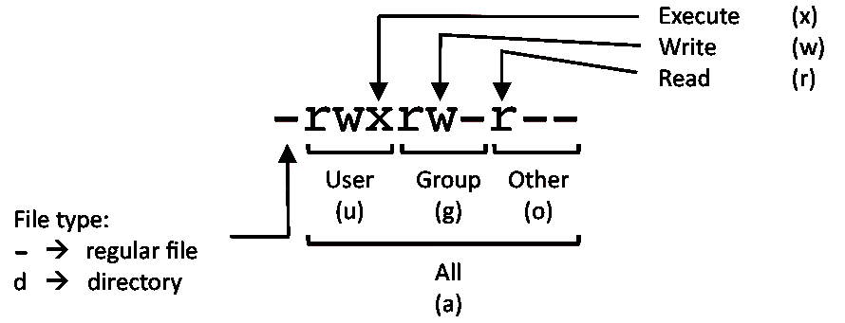

PERMISSION EXAMPLE

U G W
rwx rwx rwx chmod 777 filename
rwx rwx r-x chmod 775 filename
rwx r-x r-x chmod 755 filename
rw- rw- r-- chmod 664 filename
rw- r-- r-- chmod 644 filename

# NOTE: Use 777 sparingly!

LEGEND
U = User
G = Group
W = World

r = Read
w = write
x = execute
- = no access

8 – NETWORKING
# Display all network interfaces and ip address
ifconfig -a

# Display eth0 address and details
ifconfig eth0

# Query or control network driver and hardware settings
ethtool eth0

# Send ICMP echo request to host
ping host

# Display whois information for domain
whois domain

# Display DNS information for domain
dig domain

# Reverse lookup of IP_ADDRESS
dig -x IP_ADDRESS

# Display DNS ip address for domain
host domain

# Display the network address of the host name.
hostname -i

# Display all local ip addresses
hostname -I

# Download http://domain.com/file
wget http://domain.com/file

# Display listening tcp and udp ports and corresponding programs
netstat -nutlp

9 – ARCHIVES (TAR FILES)
# Create tar named archive.tar containing directory.
tar cf archive.tar directory

# Extract the contents from archive.tar.
tar xf archive.tar

# Create a gzip compressed tar file name archive.tar.gz.
tar czf archive.tar.gz directory

# Extract a gzip compressed tar file.
tar xzf archive.tar.gz

# Create a tar file with bzip2 compression
tar cjf archive.tar.bz2 directory

# Extract a bzip2 compressed tar file.
tar xjf archive.tar.bz2

10 – INSTALLING PACKAGES
# Search for a package by keyword.
yum search keyword

# Install package.
yum install package

# Display description and summary information about package.
yum info package

# Install package from local file named package.rpm
rpm -i package.rpm

# Remove/uninstall package.
yum remove package

# Install software from source code.
tar zxvf sourcecode.tar.gz
cd sourcecode
./configure
make
make install

11 – SEARCH
# Search for pattern in file
grep pattern file

# Search recursively for pattern in directory
grep -r pattern directory

# Find files and directories by name
locate name

# Find files in /home/john that start with "prefix".
find /home/john -name 'prefix*'

# Find files larger than 100MB in /home
find /home -size +100M

12 – SSH LOGINS
# Connect to host as your local username.
ssh host

# Connect to host as user
ssh user@host

# Connect to host using port
ssh -p port user@host

13 – FILE TRANSFERS
# Secure copy file.txt to the /tmp folder on server
scp file.txt server:/tmp

# Copy *.html files from server to the local /tmp folder.
scp server:/var/www/*.html /tmp

# Copy all files and directories recursively from server to the current system's /tmp folder.
scp -r server:/var/www /tmp

# Synchronize /home to /backups/home
rsync -a /home /backups/

# Synchronize files/directories between the local and remote system with compression enabled
rsync -avz /home server:/backups/

14 – DISK USAGE
# Show free and used space on mounted filesystems
df -h

# Show free and used inodes on mounted filesystems
df -i

# Display disks partitions sizes and types
fdisk -l

# Display disk usage for all files and directories in human readable format
du -ah

# Display total disk usage off the current directory
du –sh

15 – DIRECTORY NAVIGATION
# To go up one level of the directory tree. (Change into the parent directory.)
cd ..

# Go to the $HOME directory
cd

# Change to the /etc directory
cd /etc

